SHULL SCIENCE · JAMES A. GARFIELD LOCAL SCHOOLS
UNIT 2 TEST: CONCEPTUAL (EDULASTIC)
UNIT 2 TEST · DAY 1 · EDULASTIC BUILD SHEET · TEACHER ONLY

25 items, 34 points. Each item gives the Edulastic question type to pick, then what to type, in the order the editor asks for it. The correct answer is in bold. Images are in the edulastic folder next to this file. Turn on question and answer shuffling in the test settings in place of separate versions.

S2.1 · THE BOHR MODEL
1 MULTIPLE CHOICE 1 pt
In the Bohr model, what does it mean that an electron's energy is quantized?
A. It can only have certain set amounts of energy.
B. It can have any amount of energy, depending on its speed.
C. Its energy is highest when it is closest to the nucleus.
D. It loses energy steadily as it circles the nucleus.
Why the wrong ones are wrong: B treats energy as continuous. C reverses the levels: n = 1 is the lowest. D is the classical spiral the Bohr model was built to fix.
2 CLOZE WITH DROP DOWN 1 pt
An electron in the lowest energy level it can occupy is in the [1] state. After it absorbs energy and moves to a higher level, it is in the [2] state. To return to a lower level, it must [3] energy.
[1] ground · excited
[2] ground · excited
[3] release · absorb
Why the wrong ones are wrong: Mixing up the two states, or thinking an electron absorbs energy on the way down.
3 MULTIPLE CHOICE 1 pt
Which event moves an electron to a higher energy level?
A. The atom absorbs a photon.
B. The atom gives off a photon.
C. The atom loses a proton.
D. The atom gains a neutron.
Why the wrong ones are wrong: B is the drop, not the climb. C and D change the nucleus, not the electron's level.

S2.2 · ENERGY LEVELS, SUBLEVELS & ORBITALS
4 CHOICE MATRIX 2 pts
Mark the most electrons each sublevel can hold.
Rows: s · p · d · f
Columns: 2 · 6 · 10 · 14
Correct: s = 2, p = 6, d = 10, f = 14
Why the wrong ones are wrong: The usual slip is giving the number of orbitals (1, 3, 5, 7) instead of electrons.
5 CLOZE WITH DROP DOWN 1 pt
The n = 4 energy level has [1] sublevels. The last of them is [2]. Altogether, n = 4 can hold up to [3] electrons.
[1] 3 · 4 · 5
[2] 4d · 4f · 4g
[3] 18 · 32 · 50
Why the wrong ones are wrong: 3 sublevels and 18 electrons describe n = 3. There is no g sublevel at this level.
6 MULTIPLE CHOICE 1 pt
How many orbitals does a p sublevel have, and how many electrons can it hold?
A. 3 orbitals, 6 electrons
B. 6 orbitals, 6 electrons
C. 3 orbitals, 3 electrons
D. 1 orbital, 2 electrons
Why the wrong ones are wrong: B counts electrons as orbitals. C allows one electron per orbital. D describes s.

S2.3 · ELECTRON CONFIGURATIONS
7 LABEL IMAGE WITH DROP DOWN 2 pts
Complete the orbital diagram for sulfur, S. Pick what goes in each box.
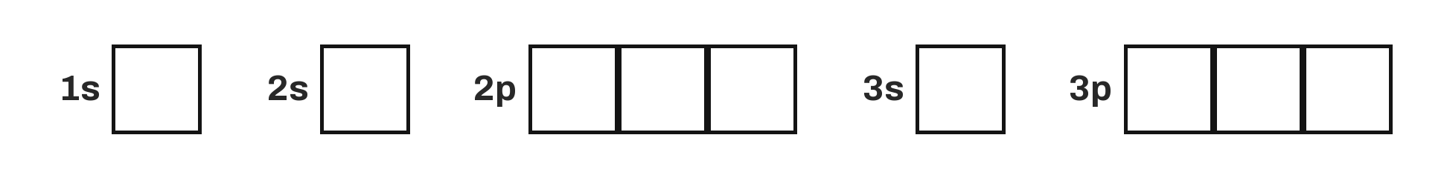
Image file: edulastic/u02_test_sulfur_orbitals.png
Put one drop-down over each of the 9 boxes, left to right. Options in every drop-down: ↑↓ · ↑ · empty.
Correct: 1s ↑↓ · 2s ↑↓ · 2p ↑↓ ↑↓ ↑↓ · 3s ↑↓ · 3p ↑↓ ↑ ↑
Why the wrong ones are wrong: Pairing the third 3p box (↑↓ ↑↓ empty) breaks Hund's rule.
8 CLASSIFICATION 2 pts
Sort each orbital diagram by the rule it breaks.
Column headings: Follows all rules · Breaks Pauli · Breaks Hund · Breaks Aufbau
Follows all rules: 2p [↑] [↑] [↑] | 3p [↑↓] [↑↓] [↑]
Breaks Pauli: 2s [↑↑] | 1s [↓↓]
Breaks Hund: 2p [↑↓] [↑] [ ] | 3d [↑↓] [↑↓] [↑] [ ] [ ]
Breaks Aufbau: 1s [↑] 2s [↑] | 1s [↑↓] 2s [ ] 2p [↑]
Edulastic shuffles the cards; type them in any order.
Why the wrong ones are wrong: Two arrows the same way in one box breaks Pauli. Pairing while a box in the same sublevel is empty breaks Hund. Skipping a lower sublevel breaks Aufbau.
9 MULTIPLE CHOICE 1 pt
Which list shows the sublevels in the order they fill?
A. 3p, 4s, 3d, 4p
B. 3p, 3d, 4s, 4p
C. 4s, 4p, 3d, 4d
D. 3s, 3p, 3d, 4s
Why the wrong ones are wrong: B and D fill by level number. C puts 4p before 3d.
10 CLOZE WITH DROP DOWN 1 pt
Titanium, Ti, has 22 electrons. Its longhand configuration is 1s² 2s² 2p⁶ 3s² 3p⁶ 4s² [1]. Its noble-gas shorthand is [2].
[1] 3d² · 4d² · 4p² · 3d⁴
[2] [Ar] 4s² 3d² · [Ne] 4s² 3d² · [Kr] 4s² 3d² · [Ar] 3d⁴
Why the wrong ones are wrong: 4d and 4p skip 3d. 3d⁴ forgets the 4s pair. [Ne] and [Kr] are the wrong core.
11 MULTIPLE CHOICE 1 pt
Which element has the configuration [Kr] 5s² 4d¹⁰ 5p⁵?
A. Iodine, I
B. Bromine, Br
C. Xenon, Xe
D. Tellurium, Te
Why the wrong ones are wrong: Bromine ends 4p⁵. Xenon ends 5p⁶. Tellurium ends 5p⁴.
12 MULTIPLE CHOICE 1 pt
Which atom's noble-gas shorthand includes 4f¹⁴?
A. Barium, Ba
B. Hafnium, Hf
C. Zirconium, Zr
D. Cesium, Cs
Why the wrong ones are wrong: Barium stops at 6s², just before 4f fills. Zirconium is in period 5 and uses 4d. Cesium stops at 6s¹.
13 MULTIPLE CHOICE 1 pt
Copper is predicted to be [Ar] 4s² 3d⁹, but it is actually [Ar] 4s¹ 3d¹⁰. Why?
A. 4s and 3d are close in energy, and a full 3d gives lower total energy.
B. 4s is higher in energy than 4p, so it empties first.
C. Copper loses an electron to become an ion.
D. Pauli's rule allows only one electron in 4s.
Why the wrong ones are wrong: B is false. C confuses the atom with an ion. D misstates Pauli: 4s holds two.

S2.4 · VALENCE ELECTRONS & IONS
14 MATCH LIST 2 pts
Match each atom to its number of valence electrons.
Sodium, Na → 1
Carbon, C → 4
Nitrogen, N → 5
Chlorine, Cl → 7
Argon, Ar → 8
Why the wrong ones are wrong: Students who count all electrons, or use the group number for groups 13 to 18 without subtracting 10, miss C, N, Cl and Ar.
15 MULTIPLE CHOICE 1 pt
Selenium is [Ar] 4s² 3d¹⁰ 4p⁴. Which electrons are its valence electrons?
A. 4s² 4p⁴, so 6
B. 4p⁴ only, so 4
C. 3d¹⁰ 4p⁴, so 14
D. All 34
Why the wrong ones are wrong: B leaves out the 4s pair. C counts the last-filled sublevels. D counts every electron.
16 CLASSIFICATION 2 pts
Sort each atom by the kind of ion it forms.
Column headings: Forms a cation · Forms an anion
Forms a cation: Potassium, K | Magnesium, Mg | Aluminum, Al
Forms an anion: Sulfur, S | Chlorine, Cl | Phosphorus, P
Edulastic shuffles the cards; type them in any order.
Why the wrong ones are wrong: Metals lose electrons (cations); nonmetals gain them (anions).
17 CLOZE WITH DROP DOWN 2 pts
Nitrogen has [1] valence electrons. It [2] [3] electrons to form the ion [4], which has the same electron arrangement as [5].
[1] 3 · 5 · 7
[2] gains · loses
[3] 2 · 3 · 5
[4] N³⁻ · N³⁺ · N⁵⁺
[5] neon · argon · helium
Why the wrong ones are wrong: Losing 5 is possible on paper but costs far more energy than gaining 3. N³⁻ has 10 electrons, like neon.
18 MULTIPLE CHOICE 1 pt
Which ion has the same electron arrangement as argon?
A. K⁺
B. Na⁺
C. Ca⁺
D. Cl
Why the wrong ones are wrong: Na⁺ matches neon. Ca⁺ has 19 electrons. Cl is a neutral atom with 17.
19 MULTIPLE CHOICE 1 pt
When iron, [Ar] 4s² 3d⁶, forms Fe²⁺, which electrons leave?
A. The two 4s electrons
B. Two 3d electrons
C. One 4s and one 3d electron
D. Two 4p electrons
Why the wrong ones are wrong: B assumes the last in is the first out. Iron has no 4p electrons (D).
20 LABEL IMAGE WITH DROP DOWN 2 pts
Label each block of the periodic table.
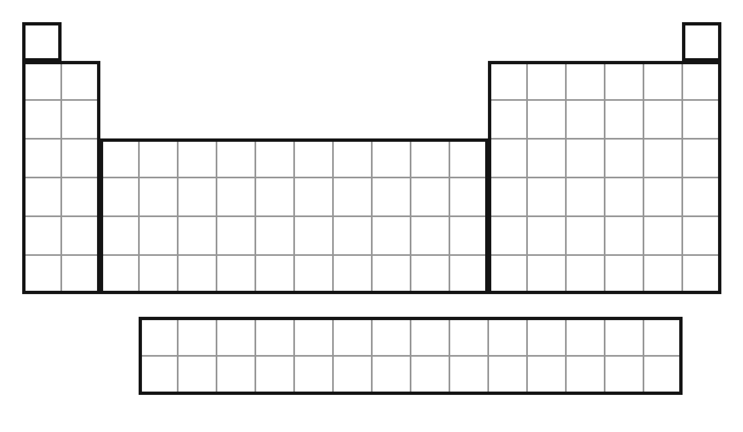
Image file: edulastic/u02_test_periodic_blocks.png
Put one drop-down inside each heavy outline: the left two columns, the middle ten, the right six, and the two rows below. Options in every drop-down: s block · p block · d block · f block. (H and He sit in their own small outlines; no drop-down needed there.)
Correct: left = s block · middle = d block · right = p block · bottom rows = f block
Why the wrong ones are wrong: Swapping d and f is the common slip.

S2.5 · ATOMIC & ELECTRON SPECTRA
21 CLASSIFICATION 2 pts
Sort each electron move by what happens to a photon.
Column headings: Absorbs a photon · Gives off a photon
Absorbs a photon: n = 1 → 3 | n = 2 → 4 | n = 4 → 6
Gives off a photon: n = 5 → 2 | n = 3 → 1 | n = 6 → 2
Edulastic shuffles the cards; type them in any order.
Why the wrong ones are wrong: Up the ladder takes energy in; down the ladder gives it out.
22 MULTIPLE CHOICE 1 pt
The diagram shows four electron drops, A to D. Which drop gives off the photon with the most energy?
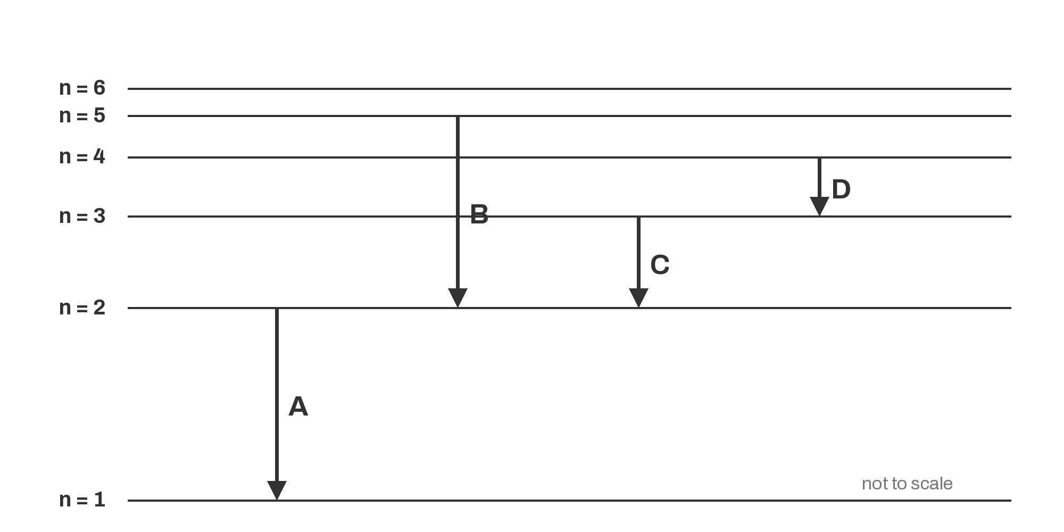
Image file: edulastic/u02_test_energy_drops.png
A. A
B. B
C. C
D. D
Why the wrong ones are wrong: B crosses the most levels but A is the biggest gap. C and D are smaller gaps.
23 CLOZE WITH DROP DOWN 1 pt
Hydrogen gives off light at 410 nm and at 656 nm. The 410 nm light has a [1] wavelength, so its photon carries [2] energy and comes from a [3] drop.
[1] shorter · longer
[2] more · less
[3] larger · smaller
Why the wrong ones are wrong: The trap is thinking a bigger number of nanometers means more energy.
24 MATCH LIST 2 pts
Match each ion to its flame-test color.
Na⁺ → Yellow
K⁺ → Lilac
Cu²⁺ → Blue-green
Ca²⁺ → Orange-red
Ba²⁺ → Pale green
Why the wrong ones are wrong: Colors are from the S2.5 notes. Li⁺ and Sr²⁺ are left out because both are red.
25 MULTIPLE CHOICE 1 pt
Why do atoms in a flame give off light?
A. Heat excites electrons, and they give off photons as they drop back down.
B. Electrons give off photons as they move up to higher levels.
C. The atoms burn and the smoke glows.
D. Protons jump between energy levels.
Why the wrong ones are wrong: B has the direction backwards. C and D are not about electrons.

